a)

b) SolidWorks .prt of Suspension

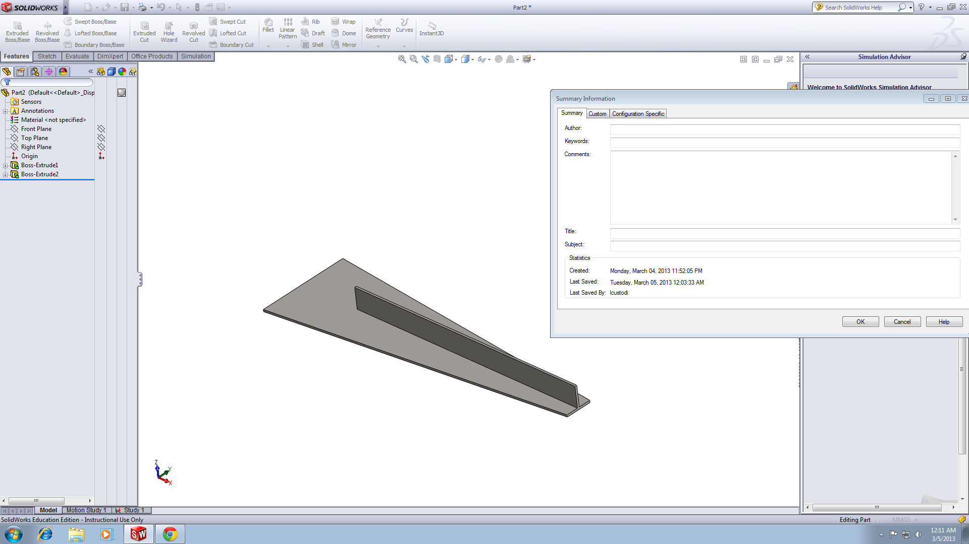

Problem #4

1. Meshed Model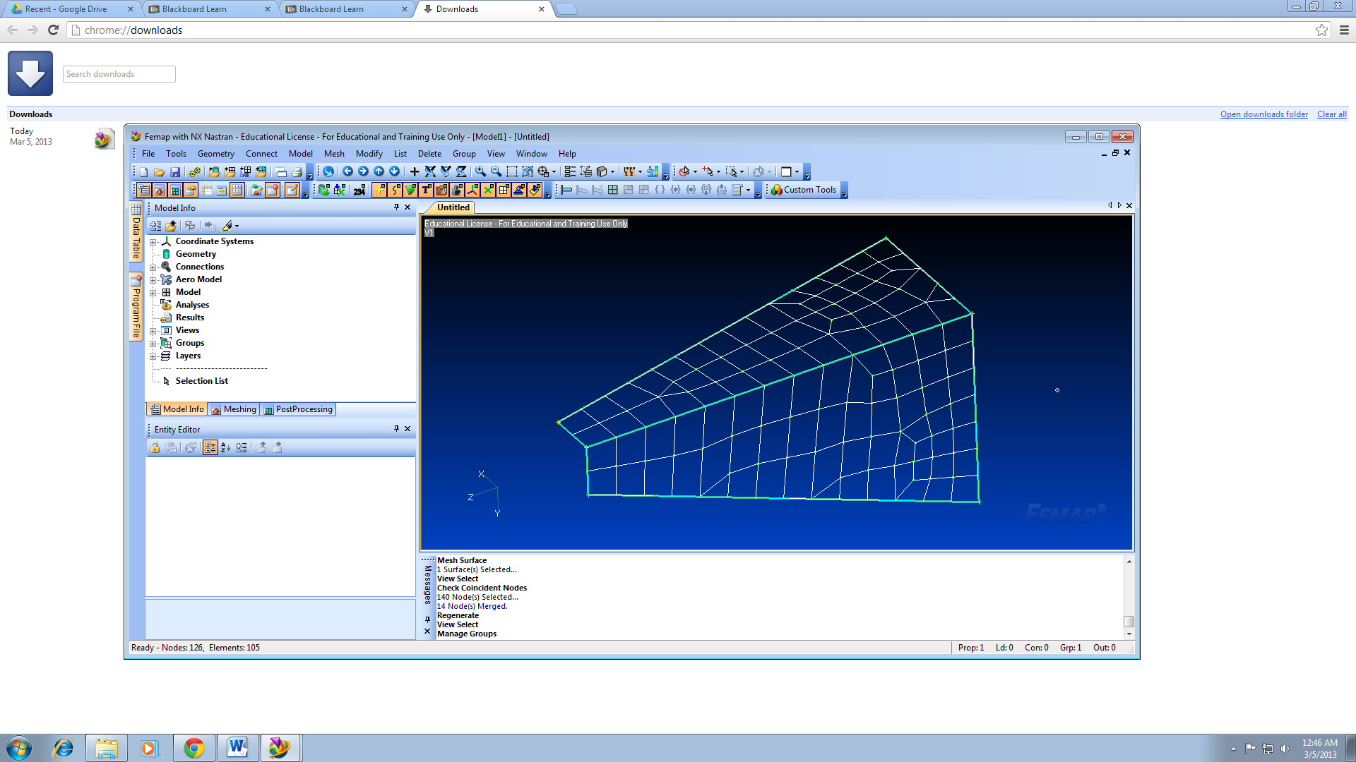
2. Model After Applying Displacement BCs

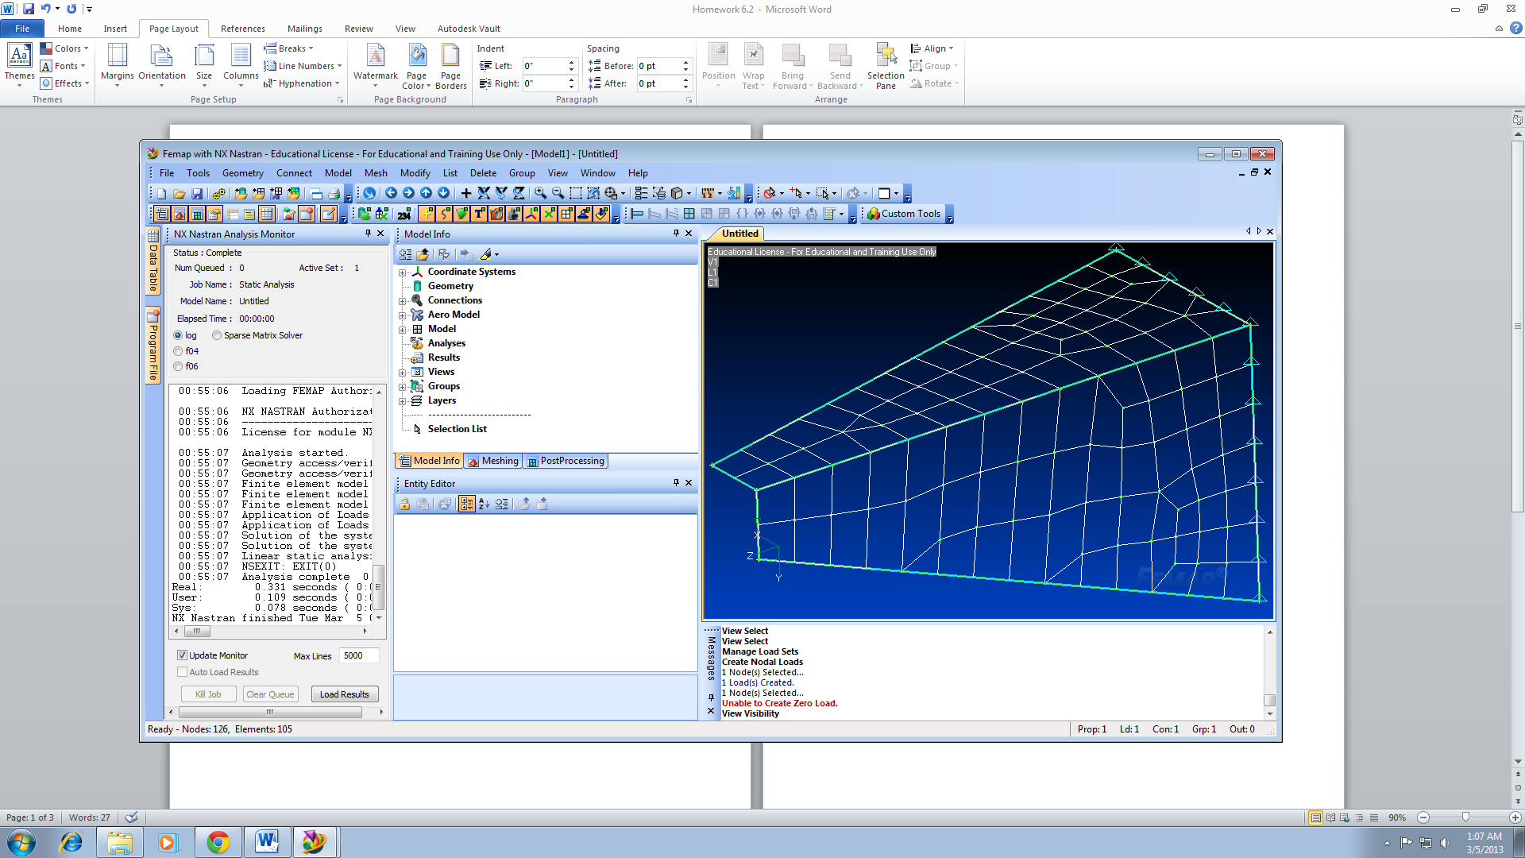

1. Model with displacement Contours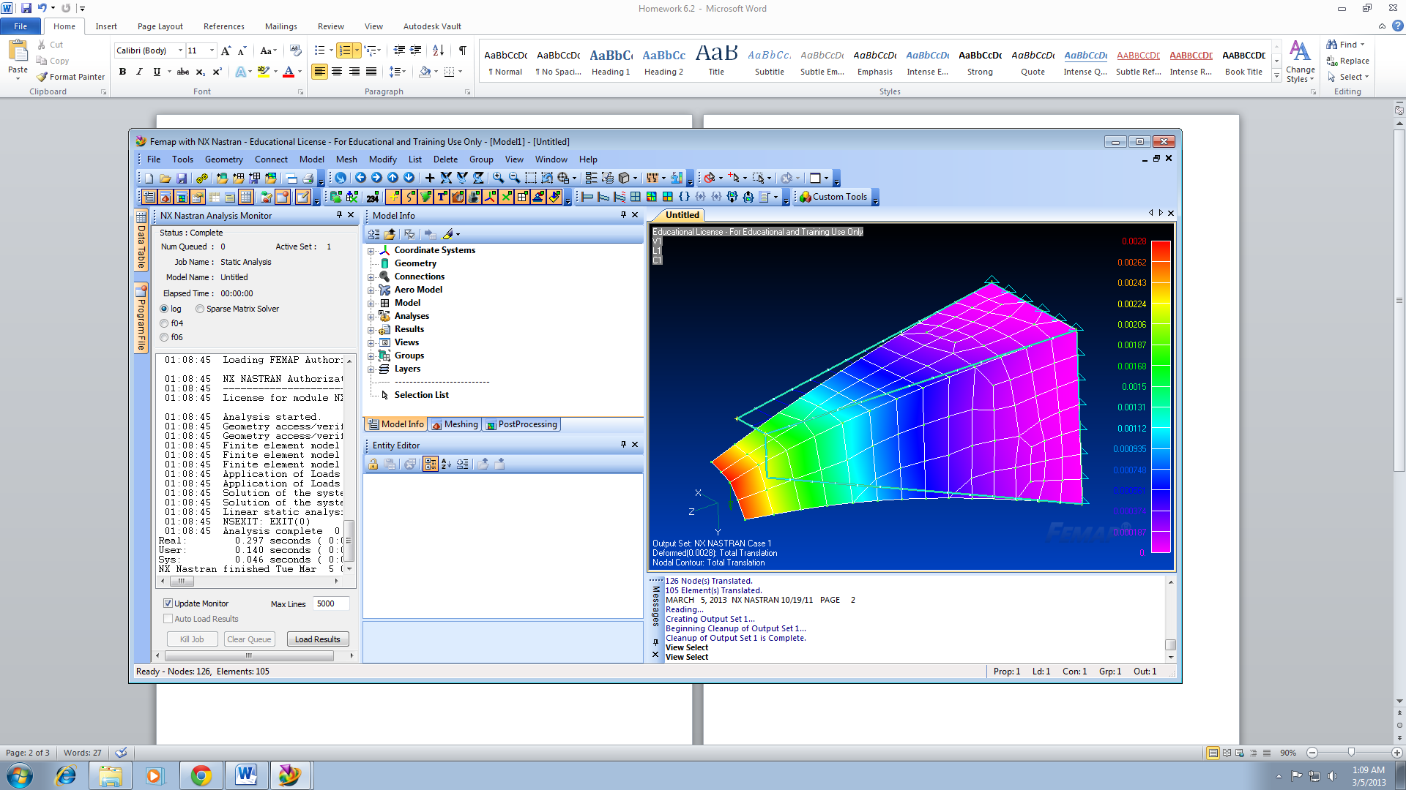
2. Model with Stress Contours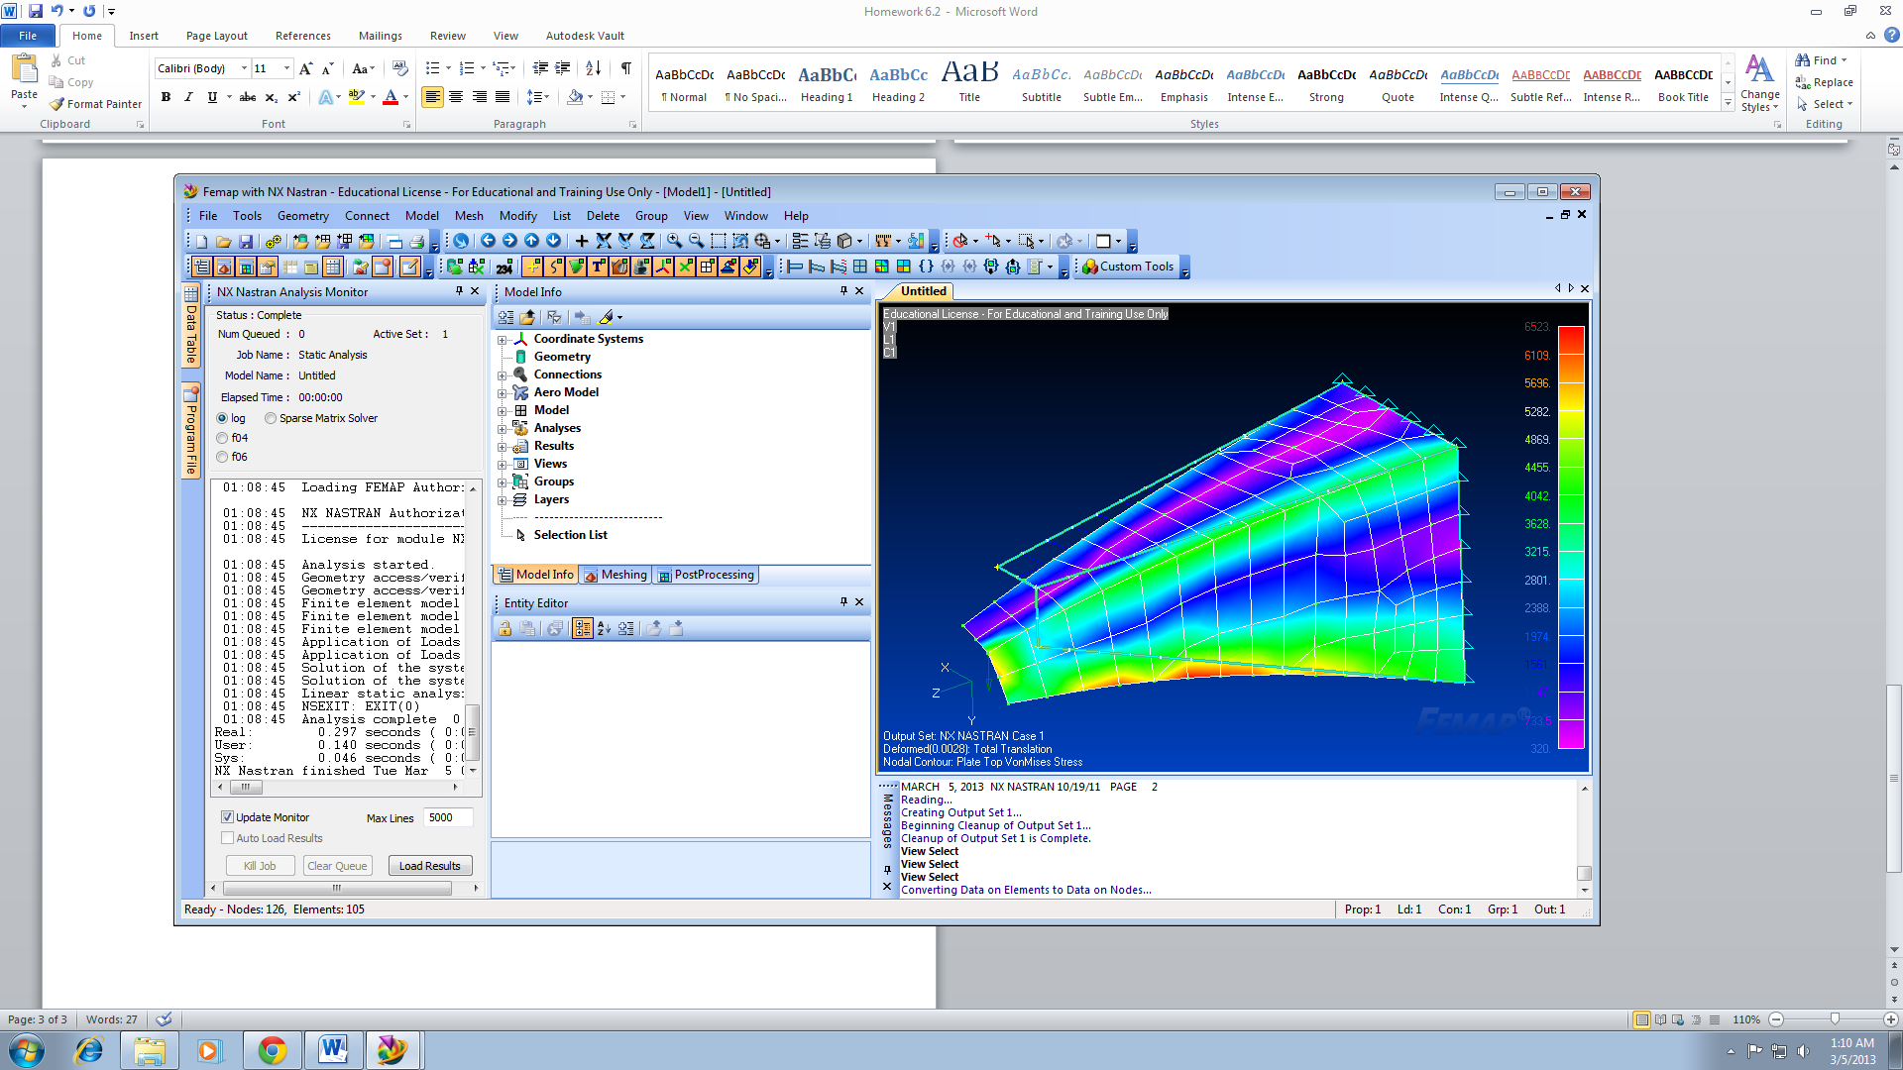

Truss Problem – Total Translation Contour